User-based collaborative filtering
The user-based collaborative filtering algorithm mainly consists of two steps.
1. Find a set of users with similar interests to the target users.
2. Find items in the collection that the user likes and that the target user has not heard of and recommend them to the target user.
Similarity
The key of step 1 is to calculate the similarity between two users. The following is a list of two common similarity calculation methods.
Given user U and user V, let N(u) represent the set of items that user U has had positive feedback on, and let N(v) be the set of items that user V has had positive feedback on.
- Jaccard
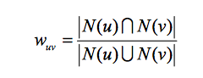
- Cosine Similarity
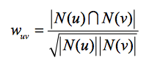
- Pearson
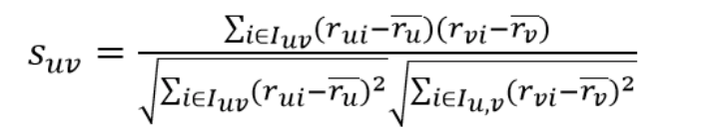

Example
Calculate the similarity between two individual users
The following is a brief introduction to the cosine similarity calculation method to get the similarity between two users.
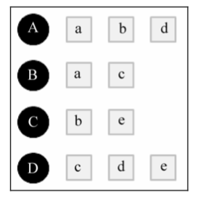
For example, user A has had behavior towards item {A,b,d}, and user B has had behavior towards item {A,c}. The cosine similarity formula is used to calculate the interest similarity between user A and user B as follows:
the similarity between A and B
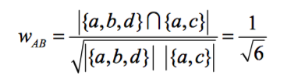
Similarly, we can calculate the similarity between user A and user C and D:
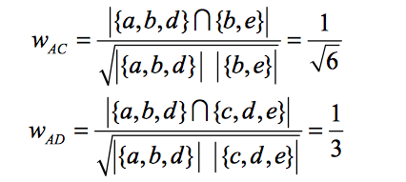

Calculate the similarity matrix between user pairs
For both users, cosine similarity is used to calculate the similarity. The time complexity of this method is order N^2. It takes a lot of time.
Therefore, we need to establish an inversion list between items and users, so that we can exclude the calculation of similarity between users who have no connection at all.
Then calculate the matrix of the co-rated items from the inversion list.
As shown in the figure below.
Calculate the matrix of co-rating items
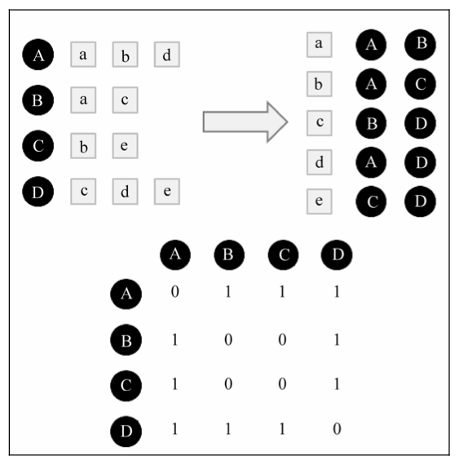
Each value in the matrix is the numerator part of the cosine similarity, and then the numerator is divided by the denominator to get the final user interest similarity.
In other words, the matrix of co-rated items in the figure above can be converted into the similarity matrix between users, and only the non-zero part can be calculated.
For example, calculate the user similarity between A and B. The value in the matrix of users A and B is 1, that is, the item they share is 1. A rated 3 items in total, B rated 2 items in total. According to the cosine similarity algorithm, the similarity is.
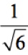

Select K users who are most similar to the target users
After the similarity between users is obtained, the algorithm will recommend to users the favorite items of K users who are most similar to their interests
The following formula measures user U's interest in item I in the algorithm
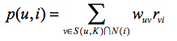
Where, S(u,K) contains K users whose interests are most similar to those of user U, N(i) is the set of users who have rated on item i, W_{uv} is the interest similarity between user u and user v, and r_{vi} is 1.

For example
Recommend target user A. Select K=3. User A has no behavior towards items c and e, so these two items can be recommended to user A. According to the algorithm, user A's interest in item c and e is:
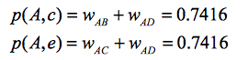

User-based collaborative filtering-python

1.MovieLens
The MovieLens data set contains multiple movie ratings by multiple users, as well as movie metadata information and user attribute information. This data set is often used as a test data set for recommendation systems, machine learning algorithms. Especially in the area of recommendation systems.
The download of the data set is:http://files.grouplens.org/datasets/movielens/，There are several versions with different amounts of data, and the data used for this article is mL-latest-small-zip. In this paper, two data tables, ratings. CSV and Movies.csv, are mainly used:
Ratings Data
userId: The ID of each user
movieId: The ID of each movie
rating: User rating, on a 5-star scale, increments by the size of half a star (0.5 stars 5 Stars)
timestamp: The number of seconds from zero on January 1, 1970 until the time the user submits the evaluation.
The order in which the data is sorted is userId, movieId.
Movies Data
movieId:The ID of each movie
title:Movie title
genres:Movie type

2.Data processing
First, we define the path to our data and use Pandas to read in:
import mathimport numpy as npimport pandas as pdfrom sklearn.model_selection import train_test_split

pd.set_option('display.max_rows', 500)
pd.set_option('display.max_columns', 500)
pd.set_option('display.width', 1000)
moviesPath = ".\\data\\movies.csv"
ratingsPath = ".\\data\\ratings.csv"
moviesDF = pd.read_csv(moviesPath, index_col=None)
ratingsDF = pd.read_csv(ratingsPath, index_col=None)
Here we split the data set in a 4:1 ratio, and print out the total number of users and movies, the number of users and movies in the training set, and the number of users and movies in the test set:
trainRatingsDF, testRatingsDF = train_test_split(ratingsDF, test_size=0.2)
print("total_movie_count:" + str(len(set(ratingsDF['movieId'].values.tolist()))))
print("total_user_count:" + str(len(set(ratingsDF['userId'].values.tolist()))))
print("train_movie_count:" + str(len(set(trainRatingsDF['movieId'].values.tolist()))))
print("test_movie_count:" + str(len(set(testRatingsDF['movieId'].values.tolist()))))
print("train_user_count:" + str(len(set(trainRatingsDF['userId'].values.tolist()))))
print("test_user_count:" + str(len(set(testRatingsDF['userId'].values.tolist()))))
Results are as follow:
total_movie_count:9066total_user_count:671train_movie_count:8381train_user_count:671test_movie_count:4901test_user_count:671
Below, the user-film rating matrix is obtained using pivot_table, and 610*8981 is obtained.
trainRatingsPivotDF = pd.pivot_table(trainRatingsDF[['userId', 'movieId', 'rating']], columns=['movieId'],
index=['userId'], values='rating', fill_value=0)
Gets the mapping of the movie ID, the user ID, and its index:
# enumerateNumbers and values# 8981movies
moviesMap = dict(enumerate(list(trainRatingsPivotDF.columns)))# 610user
usersMap = dict(enumerate(list(trainRatingsPivotDF.index)))# The matrix becomes list and each row becomes a value of list
ratingValues = trainRatingsPivotDF.values.tolist()

3.Calculating user similarity
The cosine similarity is used to calculate the similarity between users：
def calCosineSimilarity(list1, list2):
res = 0
denominator1 = 0
denominator2 = 0
for (val1, val2) in zip(list1, list2):
res += (val1 * val2)
denominator1 += val1 ** 2
denominator2 += val2 ** 2
return res / (math.sqrt(denominator1 * denominator2))
Calculate the similarity matrix between users（610*610）：
# The similarity between each user is determined by the user's rating of the movie
userSimMatrix = np.zeros((len(ratingValues), len(ratingValues)), dtype=np.float32)for i in range(len(ratingValues) - 1):
for j in range(i + 1, len(ratingValues)):
userSimMatrix[i, j] = calCosineSimilarity(ratingValues[i], ratingValues[j])
userSimMatrix[j, i] = userSimMatrix[i, j]
Next, we will find the K users who are most similar to each user, and use the preferences of these K users to recommend items to the target users, where K=10. The following code is used to calculate the 10 users who are most similar to each user:
# Find the top K users that are most similar to each user
userMostSimDict = dict()for i in range(len(ratingValues)):
userMostSimDict[i] = sorted(enumerate(list(userSimMatrix[i])), key=lambda x: x[1], reverse=True)[:10]

4.recommender movie
After getting the 10 users with the most similar interests for each user, we calculated the user's interest in each movie that he or she had not seen according to the following formula:
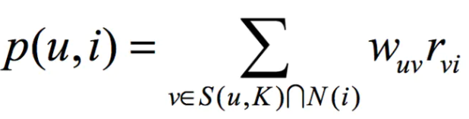

5.Code

#-*- coding: utf-8 -*-
import math
import numpy as np
import pandas as pd
from sklearn.model_selection import train_test_split

pd.set_option('display.max_rows', 500)
pd.set_option('display.max_columns', 500)
pd.set_option('display.width', 1000)

moviesPath = ".\\movies.csv"
ratingsPath = ".\\ratings.csv"
moviesDF = pd.read_csv(moviesPath, index_col=None)
ratingsDF = pd.read_csv(ratingsPath, index_col=None)

trainRatingsDF, testRatingsDF = train_test_split(ratingsDF, test_size=0.2)
print("total_movie_count:" + str(len(set(ratingsDF['movieId'].values.tolist()))))
print("total_user_count:" + str(len(set(ratingsDF['userId'].values.tolist()))))
print("train_movie_count:" + str(len(set(trainRatingsDF['movieId'].values.tolist()))))
print("test_movie_count:" + str(len(set(testRatingsDF['movieId'].values.tolist()))))
print("train_user_count:" + str(len(set(trainRatingsDF['userId'].values.tolist()))))
print("test_user_count:" + str(len(set(testRatingsDF['userId'].values.tolist()))))

trainRatingsPivotDF = pd.pivot_table(trainRatingsDF[['userId', 'movieId', 'rating']], columns=['movieId'],
index=['userId'], values='rating', fill_value=0)

# enumerate numbers and values
# 8981 movies
moviesMap = dict(enumerate(list(trainRatingsPivotDF.columns)))
# 610 users
usersMap = dict(enumerate(list(trainRatingsPivotDF.index)))
# The matrix becomes list and each row becomes a value of list
ratingValues = trainRatingsPivotDF.values.tolist()

def calCosineSimilarity(list1, list2):
res = 0
denominator1 = 0
denominator2 = 0
for (val1, val2) in zip(list1, list2):
res += (val1 * val2)
denominator1 += val1 ** 2
denominator2 += val2 ** 2
return res / (math.sqrt(denominator1 * denominator2))

# The similarity between each user is determined by the user's rating of the movie
userSimMatrix = np.zeros((len(ratingValues), len(ratingValues)), dtype=np.float32)
for i in range(len(ratingValues) - 1):
for j in range(i + 1, len(ratingValues)):
userSimMatrix[i, j] = calCosineSimilarity(ratingValues[i], ratingValues[j])
userSimMatrix[j, i] = userSimMatrix[i, j]

# Finding the top K users that are most similar to each user
userMostSimDict = dict()
for i in range(len(ratingValues)):
userMostSimDict[i] = sorted(enumerate(list(userSimMatrix[i])), key=lambda x: x[1], reverse=True)[:10]

# Use these K preferences to recommend movies that the target audience has not seen
userRecommendValues = np.zeros((len(ratingValues), len(ratingValues[0])), dtype=np.float32) # 610*8981

for i in range(len(ratingValues)):
for j in range(len(ratingValues[i])):
if ratingValues[i][j] == 0:
val = 0
for (user, sim) in userMostSimDict[i]:
val += (ratingValues[user][j] * sim)
userRecommendValues[i, j] = val

userRecommendDict = dict()
for i in range(len(ratingValues)):
userRecommendDict[i] = sorted(enumerate(list(userRecommendValues[i])), key=lambda x: x[1], reverse=True)[:10]

# Converts the initial index to the original user ID and movie ID
userRecommendList = []
for key, value in userRecommendDict.items():
user = usersMap[key]
for (movieId, val) in value:
userRecommendList.append([user, moviesMap[movieId]])

# Converts the movie ID of the recommended result to the corresponding movie title
recommendDF = pd.DataFrame(userRecommendList, columns=['userId', 'movieId'])
recommendDF = pd.merge(recommendDF, moviesDF[['movieId', 'title']], on='movieId', how='inner')
print(recommendDF.tail(10))
About training time: 10 min

